Exposures to Allergenic Pollen for General U.S. Population

# Abstract

Airborne allergens such as pollen, which has been reported to act synergistically with common air pollutants, such as ozone, will cause allergic airway disease (AAD) and dermal disease. We calculated both the temporal and spatial distributions of pollen concentrations in nine climate zones based on either the mechanistic models or statistical models using ArcGIS and VERDI. Census data were used to generate a demographic distribution by age and sex in nine climate zones in the United States. A probabilistic model was developed by considering the microenvironmental dynamics of the pollens in conjunction with the activity patterns of the population. Main processes considered in the model were microenvironmental transport and deposition and dermal transfer of pollens when people come in contact with airborne pollen in pollen seasons . Estimates of exposure to allergenic pollen were obtained by using the Monte-Carlo method in Matlab for each of the the climate zones in the U.S.. Finally, we used global sensitivity analysis to estimate the sensitivity of physical parameters in this model which consists of three different exposure routes (inhalation, dermal contact, and ingestion) to determine their relative importance.

# Introduction

Airborne allergenic pollen, which has been found to act synergistically with common air pollutants, such as ozone, will cause allergic airway disease (AAD) and related rising public health costs (Lamb, Ratner et al. 2006; Singh, Axelrod et al. 2010). One third of the US population are impacted by allergic diseases, including asthma, hay fever, rhinitis, and atopic dermatitis (Bielory, Lyons et al. 2012). These allergic diseases can potentially be triggered and exacerbated by allergenic pollen, such as birch and oak, under climate change scenarios (Shea, Truckner et al. 2008). Synergism of pollen with other common atmospheric pollutants under conditions of climate change has been identified and has enhanced the severity of AAD (Adhikari, Reponen et al. 2006).

Exposures to allergenic pollen can occur via inhalation and dermal contact, as well as unintentional ingestion ([Sofiev, Belmonte et al. 2013](#_ENREF_17" \o "Sofiev, 2013 #869)).

# Background Information

## Pollen and allergy

Rhinitis, conjunctivitis and asthma are often considered as the typical clinical pictures of allergy to pollen, and they often occur in the same patient simultaneously during the pollen season (Sofiev, Belmonte et al. 2013). Asthma is a chronic inflammatory disease of the airways characterized by recurrent episodes of wheezing, breathlessness, chest tightness and coughing (Bateman, Hurd et al. 2008). Exposure to allergens represents a key factor among environmental determinants of asthma, which also include air pollution (Eder, Ege et al. 2006). Allergic rhinitis is clinically defined as a symptomatic disorder of the nose induced by an IgE-mediated inflammation after allergen exposure of the membranes lining the nose. Symptoms of rhinitis include rhinorrhea, nasal obstruction, nasal itching and sneezing which are reversible spontaneously ([Brożek, Bousquet et al. 2010](#_ENREF_6" \o "Brożek, 2010 #24)) or under treatment. Pathophysiological and clinical studies have strongly suggested a relationship between rhinitis and asthma. However, epidemiology provides the most convincing data, showing that the prevalence of asthma in patients with rhinitis varies from 10 to 40 % depending on the study (Sofiev, Belmonte et al. 2013). Moreover, allergic rhinitis is correlated to, and constitutes a risk factor for, the occurrence of asthma. Taken together, these data have led to the concept that upper and lower airways may be considered as a unique entity influenced by a common, evolving inflammatory process ([Passalacqua and Durham 2007](#_ENREF_14" \o "Passalacqua, 2007 #25)). Conjunctivitis is also commonly associated with pollen-induced rhinitis.

Sensitization occurs at the site of allergen exposure, such as airways, but can also occur through the dermal tract. However, not everybody who is exposed will become sensitized and have allergies. Aside from the individual exposure conditions, there is a high variability in the individual responsiveness to a given allergen dose.

The most important allergen carriers in outdoor air as well as in indoor air are pollen – with a diameter between 15 and 60 µm – from anemophilic plants such as trees, grasses and weeds. In this thesis, we discuss five different species, which are ragweed (Ambrosia), mugwort (Artemisia), birch (Betula), grass (Gramineae) and oak (Quercus). However, whole pollen grains are too large to penetrate the small airways. Since pollen is able to evoke IgE-mediated allergic reactions within seconds after contact with the mucosa, pollen allergens must be extremely water soluble and readily available. In fact allergen liberation from pollen grains can occur on the mucosal surface of the upper respiratory tract after exposure to pollen (Behrendt and Becker 2001). Symptoms can be explained by the interaction between the antigen and its corresponding IgE antibody and this phase is situated at the end of a cascade of events leading to allergy. The experimental data

## Pollen Season

Using different methods of observation and measurement, phenological events and pollen counts can be traced back to the same phenomenon, the flowering of plants. Similarly, both kinds of data can be modeled in many respects using a similar set of observation-based models. Simple regression models can predict entry dates of phenological phases and likewise the start, peak and end of the pollen season or, given a greater number of independent variables, the day to day variability of the pollen counts. Phenological models will equally well predict the entry dates of phenological phases as well as the start, peak and end of the pollen season. Phenological models are sometimes grouped into the class of process-based models (Chuine, Belmonte et al. 2000), because they are built on assumptions rooted in experimental results on plant physiological responses to various environmental variables. Methods.

## Data Collection

### Pollen Data Collection

Observed airborne pollen data from 85 monitor stations from 1994 to 2010 at nine different climates zones in the US (Figure 4) were studied to examine the annual mean and peak value of daily concentrations of five different species of pollens (Ambrosia, Artemisia, Betula, Gramineae, and Quercus). Regression analyses were used to simulate start dates and season lengths of these five different kinds of pollen for the 17 years’ data in the contiguous US (CONUS). For most of the studied stations, comparison of mean pollen indices between the periods of 1994–2000 and 2001–2011 showed that these five different pollen species were observed to flower 1–2 weeks earlier; annual mean and peak value of daily pollen concentrations tended to increase by 13.6 %–248 %. The observed pollen season lengths varied for Ambrosia, Artemisia, Betula, Gramineae and Quercus across the different monitoring stations in the United States. Optimum initial date and base temperature for start date was found to be 25th July for Ambrosia [Figure 9], 11th April for Artemisia is[Figure 10], 29th March for Betula [Figure 11], 28th April for Gramineae [Figure 12], and 22nd March for Quercus [Figure 13]. The pollen season lasts roughly 3months for each species, respectively. Simulation results indicate that responses of these different kinds of pollens to climate are expected to vary for different regions. Observed airborne pollen counts were obtained from monitoring stations of the American Academy of Allergy Asthma and Immunology (AAAAI) located in 9 different climate regions. The reported pollen data were classified only at the level of genus. Species under genus of Ambrosia, Artemisia, Betula, Gramineae or Quercus were not differentiated. Data used here are from March to September, which covers all the pollen season for all kinds of pollen species discussed above. The spatial distribution scenario of Betula in 2004 is displayed as an example using VERDI. We are using logarithm instead of linear to make the figure clearer.

### Population Data and Exposure Factors

The population data are from the United States census bureau. The demographic data contain general population information ([U.S 2010](#_ENREF_18" \o "U.S, 2010 #30)), in which the state-level population is classified by age group and sex. We combined those data, using ArcGIS to generate the population data on age and sex in 9 different climate regions to couple with the corresponding pollen data.

The Exposure Factor data were obtained from USEPA’s Exposure Factors Handbook ([Agency 2010](#_ENREF_2" \o "Agency, 2010 #5)). These factors include the value of inhalation, dermal contact frequency, skin surface, hand surface, indoor time/outdoor time and other exposure factor data in different age groups and sex. In each age group, ten different percentiles level (0%-95%) and mean values of exposure factors are used to generate the exposure scenario in the nine climate zones.

These exposure factor data are all in country-level. A basic assumption is that the inhalation rate of the residents, as well as other exposure data, in different climate regions are identical, although the temperature, illumination time and other environmental factors may surely affect those values.

## Exposure Method Selection

### Inhalation

Exposure can be quantified by multiplying the concentration of an agent and the exposed duration. Exposure can be instantaneous when the contact between an agent and a target occurs at a single point in time and space. The summation of instantaneous exposures over the exposure duration is called the time-integrated exposure. Equation shows the time-integrated exposure(Fogh and Andersson 2000).



where:

1. E = Time-integrated exposure (mass/volume),
2. t2– t1 = Exposure duration (ED) (time),
3. C = Exposure concentration as a function of time (mass/volume).
4. I = Inhalation factors (volume/time).

Time-averaged exposure was obtained by dividing the integrated exposure by exposure duration.

In the current study, since the time step is 1 day, we integrated the concentration through the whole pollen season (an average time about 3 months) for each species, and we used pollen counts which are considered as a more appropriate measurement of the scenario.

Then we considered the indoor and outdoor exposures as in equations and .

Outdoor:



Indoor



1. Where E = Time-integrated exposure (mass/volume),
2. t2– t1 = Exposure duration (ED) (time),
3. C = Exposure concentration as a function of time (mass/volume).
4. I = Inhalation factors (volume/time).
5. and are ventilation rate and indoor deposition velocity, respectively.

### Dermal Exposure and Ingestion

Dermal exposure to volatile chemical compound is fully studied already (Hu, Zhang et al. 2011), however, the reports to the dermal exposure to pollen remains rare. We used dry deposition model to estimate the adherence of pollen on human skins.

The dry deposition model assumed that the transport of material to the surface is to be governed by three resistances in series: the aerodynamic resistance , the quasi-laminar layer resistance , and the surface or canopy resistance . The total resistance, by definition, is the inverse of the deposition velocity

|  |  |  |
| --- | --- | --- |
|  |  |  |

For particle dry deposition, becomes



where is the particle settling velocity

|  |  |  |
| --- | --- | --- |
|  |  |  |



|  |  |  |
| --- | --- | --- |
|  |  |  |
|  |  |  |

Where is the density of the particle, is the particle diameter, g is the gravitational acceleration, μ is the viscosity of air, and is the slip correction factor.

|  |  |  |
| --- | --- | --- |
|  |  |  |
|  |  |  |



Where Sc is the Schmidt number, St is the Stokes number, and D is the molecular diffusivity,

So the direct deposition to the skin can be calculated now

1 indoor

|  |  |  |
| --- | --- | --- |
|  |  |  |

2 outdoor

|  |  |  |
| --- | --- | --- |
|  |  |  |

Where

1. the mass of the substance on the skin surface
2. is the exposed skin area.
3. The parameters and are ventilation rate and indoor deposition velocity, respectively.

### Exposure Calculation Method

Monte-Carlo method was used to generate the exposure data. We generate the activity data of 100000 people in each region. Also we normalized the pollen data to fit the size of group. by randomly multiply the value in each data set one by one and repeat this method 5 times. The mean of the results could be described as the population exposure to pollen.

## Sensitivity Analysis

Sensitivity analysis is the analysis of how the uncertainty in the output of a mathematical system or modeling (numerical or otherwise) can be apportioned to variety sources of uncertainty in its inputs.[1]

Mean daily mass intake exposure to pollens was selected as a metric for testing the system’s sensitivity to multiple inputs and parameters. Global sensitivity analysis was performed based on Morris’s Design. This design estimate the main effect of a parameter by computing a number of local sensitivities at random points of the parameter space. The mean of these randomized local sensitivities indicates the overall influence of a given parameter on the output metric, while the corresponding standard deviation indicates the effects of interacting and nonlinearity.

In the current study, each of the 17 parameters(Table 1) was sampled 3600 times according to the Morris method from 200 trajectories (each has 18 steps) in the parameter space. Each of the parameters in the simulation was perturbed from 50% to 150% of its base value or its distribution while we keep other parameters unchanged in the same time.

The mean daily exposure for sensitivity analyses was normally generated using 10000 “virtual men” in each climate regions in the flowering season. Equation was used to calculate the Normalized Sensitivity Coefficients (NSC) at a local point.

|  |  |  |
| --- | --- | --- |
|  |  |  |

In this equation, the NSCi,j is the NSC for exposure route i (inhalation, ingestion, dermal) in different climate regions j. The p is the input parameter values matrix, and r is the corresponding daily mean output of the exposure effect. The Δr and Δp is the corresponding perturbation of the parameter values and perturbation of the output, respectively. The global NSC of a certain parameter, NSCg could be defined as the mean of the corresponding local sensitivities. We obtained the absolute mean for each route and region by averaging the NSC values for that route and region. The mean standard deviations, in a similar way , are average over each exposure path and different climate regions. Then these values could be used to evaluate the interaction and nonlinearity effect of input parameters on modeling output

## Statistics of Concentrations, Exposure and Sensitivity Analysis

# To generated statistics of concentrations, surface loading, exposures and sensitivity analysis, simulations were conducted using 100000 “virtual residents” in these 9 different climate regions. Each resident will experience the whole flowering season with 5 kinds of pollens in different scenarios (outdoor and indoor). Result and Discussion

## Pollen Concentration and Surface Loading.

Figure 9 - Figure 13 are time series of observed daily concentrations of birch, oak, ragweed, mugwort and grass pollen from 1994 to 2010 at UMDNJ and Cherry Hill monitoring stations in New Jersey, U.SA. The start dates of pollen of different species are varied. The pollen season ranges from early March to late October. We also discovered that the peak values often appear in the middle of the pollen seasons. Figure 14 shows the spatial distribution of pollens of Quercus in the start date (March 15th) in the national wide scale. The peak value observed in the figure was 4 in the southwest.

The Figure 15 to Figure 19 summaries the cumulative probability of pollen concentration in different climate regions. The reported peak values were 1794 for Ambrosia, 1242 for Artemisia, 1827 for Betula, 1320 for Gramineae and 1423 for Quercus, respectively. Different climate regions show different pollen concentrations. In the Northeast, Central and East North Central climate regions, the mean concentrations of Betula and Quercus are the higher than those in other climate regions. In the West, South and Southwest climate regions, Ambrosia and Artemisia shows the high concentrations.

The surface loading was calculated based on small particle transport model and dry deposition model and Einstein-stokes equation. The key parameter is the pollen deposition rate, which is 0.0909 grain/m2 for airborne pollen. This parameter is affected by many physical parameters which are listed in Table 3.

Indoor and outdoor time of human would affect the surface loading rate significantly (Zhang, Y., et al. (2013)). The parameter ventilation rate is carried out to illustrate the difference between indoor and outdoor pollen concentrations. The outdoor concentration of pollen is normally 5-8 times higher than indoor concentration. There is no reports about pollen shows that if this prediction is valid. Similar methods and data are reported mainly about particulate matters (PM2.5 and PM10) and pesticides (Zhang, Y., et al. (2013)).

## Exposures to Pollen

While the female and male residents distributions of body weight, inhalation rate and body skin surface are different, no significant differences in simulated exposures between female and male residents were identified based on a statistic test. Thus data from all residents were combined. we used normalized method to scale down the size of the population in each climate region to 100000, so the exposure to pollen in each climate region could be compared. The distribution curve by age is maintained in every region. Figure 20 to Figure 21 show the simulated cumulative probability of residents’ daily exposures to pollen under three different exposure routes. The medians of the daily exposures of Ambrosia, Artemisia, Betula, Gramineae, Quercus were 2.3×10-3, 1.2×10-3, 9.5×10-2, 3.2×10-3,1.4×10-2, respectively.

## Sensitivity Analysis

The global sensitivity of the simulated exposures to different 18 parameters is illustrated in Figure 25 and Figure 26, for Central Climate Region and Southeast Climate Region, respectively. Overall, the global NSC of all parameters varied between 0.0 and 0.35, indicating the robustness of this modeling approach. Ingestion exposure were more sensitive to parameter perturbations, with average absolute global NSC, | NSCg |, being 0.15 to 0.35. Sensitive parameters included: viscosity of air(µ), diameter of pollen(Dp), friction velocity(u*) and hand surface rate (Sr). Inhalation exposure was less sensitive to modeling parameters. The outliers are friction velocity (u*), diameter of pollen (*Dp*), indoor time (Ind), mean free path of air molecules (λ). Total exposures has nearly the same sensitive parameters as inhalation exposure.

High interaction and nonlinearity effects among parameters were found in dermal contact and ingestion routes for pollen exposures. Average interaction effects STD being 0.3 and 0.6, respectively. Parameters with high interaction and nonlinearity effects included friction velocity (u*), viscosity of air (µ), low interaction effects were found for exposure parameters in inhalation route. They are hand to mouth frequency (Fr) .This resulted from the fact that only infants and young people often tend to touch their mouth and face using hand. And these people are only a small part of the whole population.

We can see that in different region (figure 25 and figure 26) the parameter sensitivities are slightly different. This could be explained as the effect of the proportion of different age groups of the population in each region. Young people tend to be more sensitive to airborne pollen both in inhalation and dermal contact routes, while the adults are less sensitive to them.

The ventilation and deposition rate coefficients depend on surface characteristics, temperatures and pesticide physicochemical properties such as fugacity. Data on these dependencies are extremely limited for pollen deposition and ventilation. The values of Vd and u* used in the current study were derived from references (Hu, X., et al. (2011).) on particulate matter and small particles. Widely different pollen dermal contact effect due to hand touch have been reported in the literatures ( Brożek, J. L., et al. (2010) )( Behrendt, H. and W.-M. Becker (2001))

# Conclusion

The modeling system developed based on physical processes and human activity data and demographical data in the current study, can be easily adapted to simulated risks and exposure to particulate matter(PM) which is also believed to be a major pollutant in the air in similar environments or small scaled units such as cities or certain census. Furthermore, sensitivity analyses of the modeling system provides helpful information for planning measurements related to investigation of health risks associated with exposures to pollens or other kinds or particulate particles in the environments.

# Figure

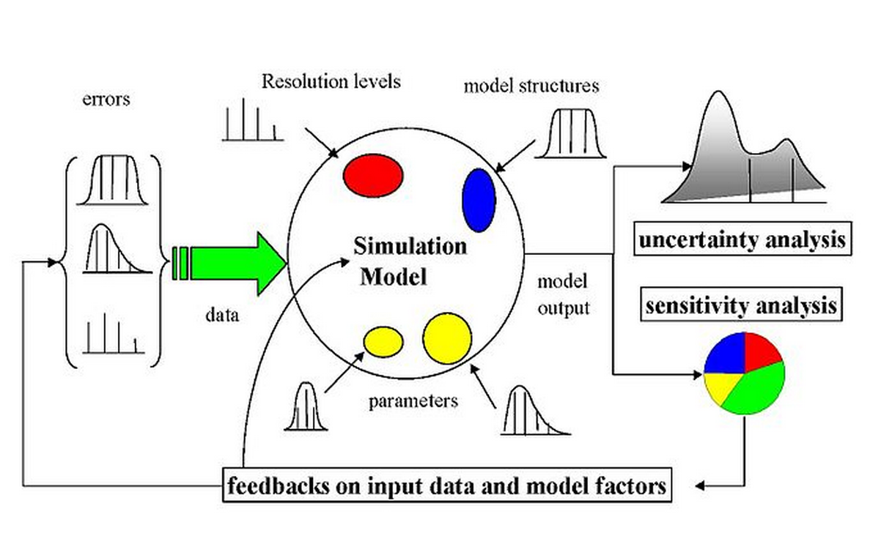

Figure 1 The scheme of a possibly sampling-based sensitivity analysis. Uncertainty would arise from different sources—errors in the data, parameter estimation procedure, and alternative model structures—they are propagated through the model for uncertainty analysis and their relative importance is quantified via sensitivity analysis.



Figure 2 There different intake routes of the pollens. Route of Inhalation are calculated and shown to be the dominated route of pollen intake. The exposure from inhalation is about 100 times than the other two routes which are based on the skin contact to pollens.



Figure 3 Schematic diagram of modeling population exposure to pollen in 9 climate regions. Concentrations and surface loading of pollen were simulated based on observed daily pollen counts from AAAAI monitoring stations. Exposures to pollens were simulated based on the concentration profiles and activity data of different groups by ages and sex from United States Census Bureau. The intake dose calculated from exposure modeling are then used as input to conduct sensitivity analysis.

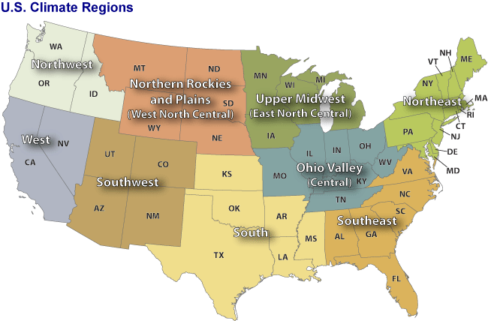

Figure 4 Nine climate regions in the contiguous United States. Through climate analysis, National Climatic Data Center scientists have identified nine climatically consistent regions within the contiguous United States which are useful for putting current climate anomalies into a historical perspective(Karl and Koss 1984)

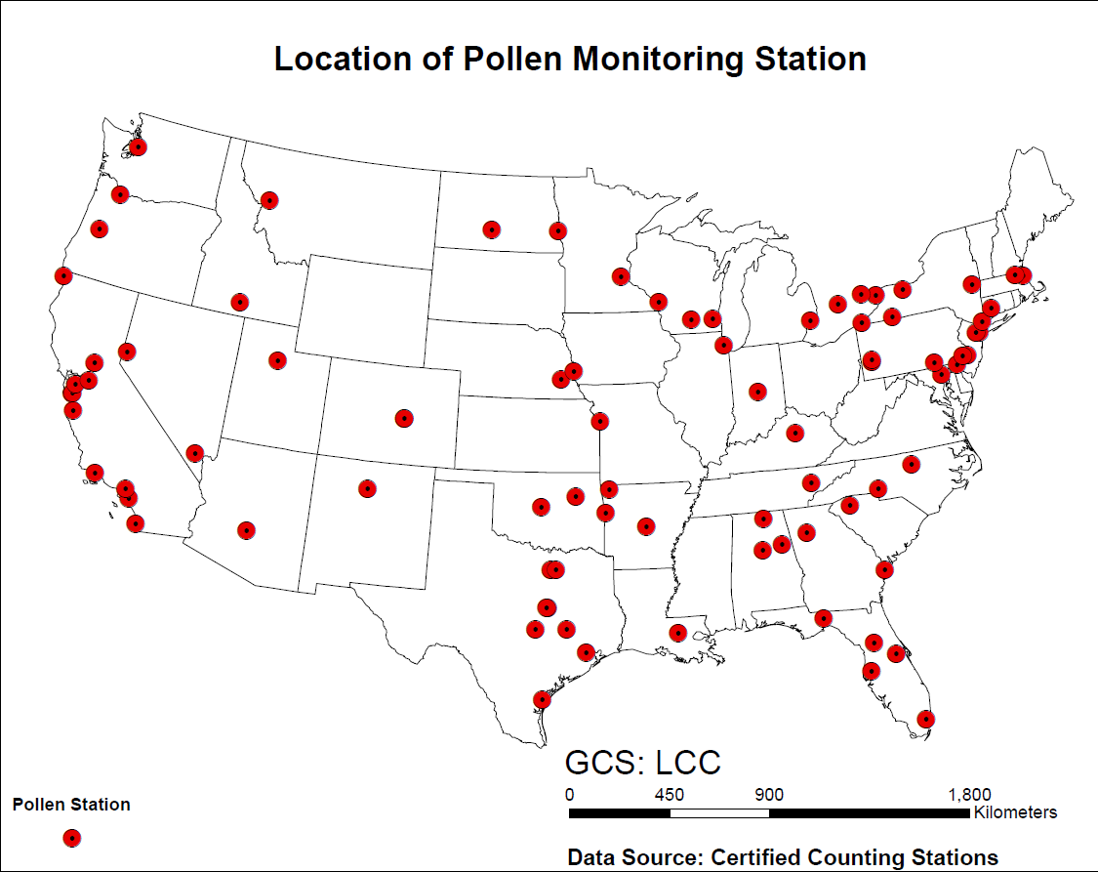

Figure 5 Locations of 87 monitor stations for airborne pollen in the United States. Pollen counts data were obtained from those monitor stations in each climate regions.



Figure 6 Activity data of human inhalation rate by weight of male and female, respectively. The data are from EFH handbook (Agency 2010). There are 14 age groups from the original data resources, for each gender. The age groups are 0-1 year, 1-2 years, 2-3 years, 3-6 years, 6-11 years, 11-16 years, 16-21 years, 21-31 years, 31-41 years, 41-51 years, 51-61 years, 61-71 years, and 71-81 years. The percentiles are from 5th to 95th.



Figure 7 Activity data of human inhalation rate of male and female, respectively. The data are from EFH handbook (Agency 2010). There are 14 age groups from the original data resources, for each gender. The age groups are 0-1 year, 1-2 years, 2-3 years, 3-6 years, 6-11 years, 11-16 years, 16-21 years, 21-31 years, 31-41 years, 41-51 years, 51-61 years, 61-71 years, and 71-81 years. The percentiles are from 5th to 95th.



Figure 8 Activity data of human inhalation rate of male and female, respectively. The data are from EFH handbook (Agency 2010). There are 17 age groups from the original data resources, for each gender. The age groups are 1-3 months, 3-6 months, 6-12 months, 1-2 years, 2-3 years, 3-6 years, 6-11 years, 11-16 years, 16-21 years, 21-31 years, 31-41 years, 41-51 years, 51-61 years, 61-71 years, and 71-81 years.81 years and older. The percentiles are from 5th to 95th.





Figure 9 Time series of observed daily pollen concentration of Ambrosia at Cherry Hill(top) and Newark(Bottom) monitor stations which locate in the Northeast Climate Zones. The pollen data are from National Allergy Bureau(Bureau 2010).





Figure 10 time series pollen concentration of Artemisia in Cherry Hill (top) and Newark(Bottom) monitor stations which locate in the Northeast Climate Zones. The pollen data are from National Allergy Bureau(Bureau 2010) we can see that the start date of Artemisia is August 11th.the flowering season lasts 3 months. The peak values appear from early September to ear October.





Figure 11 time series analysis of pollen concentration of Betula in Cherry Hill (top) and Newark(Bottom) monitor stations which locate in the Northeast. The pollen data are from National Allergy Bureau(Bureau 2010). We can see that the start date of Betula is March 29th.the flowering season lasts 3 months. The peak values appear from middle of the April to last May.





Figure 12 time series analysis of pollen concentration of Gramineae in Cherry Hill (top) and Newark (Bottom) monitor station which locate in the Northeast. The pollen data are from National Allergy Bureau(Bureau 2010). We can see that the start date of Gramineae is April 28th.the flowering season lasts 3 months. The peak values appear from last May to early June.



Figure 13 Quercus time series analysis of pollen concentration of Ambrosia in Cherry Hill (top) and Newark (Bottom) monitor stations which locate in the Northeast. The pollen data are from National Allergy Bureau(Bureau 2010) We can see that the start date of Quercus is March 22th.the flowering season lasts about 3 months. The peak values appear from late April to early June.

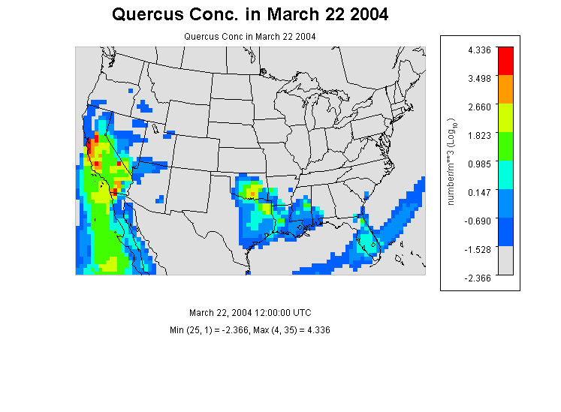

Figure 14 Quercus Concentration in the contiguous U.S. at 12:00 (UTC) in March 22 in 2004. We can see that in southwest coast ,there is already some pollens exists, but the concentration is very low. in other parts of the states, there remains few pollens.



Figure 15 The observed cumulative probability distributions of Ambrosia’s pollen concentration in the 9 nine climates regions.



Figure 16 The observed cumulative probability distributions of Artemisia’s pollen concentration in the 9 climates regions. The concentration profile in southwest is slightly smooth than in other climate regions.



Figure 17 the simulated cumulative probability distributions of Betula’s pollen concentration of populations in the 9 climates regions.



Figure 18 the simulated cumulative probability distributions of Gramineae’s pollen concentration of populations in the 9 climates regions.



Figure 19 the simulated cumulative probability distributions of Quercus’ pollen concentration of populations in the 9 climates regions.



Figure 20 Simulated cumulative probability distribution of daily exposure of population to Ambrosia pollen in different climate zones. Data were from simulation results of 100000 virtual residents in each climate zones under three different exposure routes.



Figure 21 simulated cumulative probability distribution of daily exposure of population to pollen of Artemisia in different climate zones. Data were from simulation results of 100000 virtual residents in each climate zones under three different exposure routes.



Figure 22 simulated cumulative probability distribution of daily exposure of population to pollen of Betula in different climate zones. Data were from simulation results of 100000 virtual residents in each climate zones under three different exposure routes.



Figure 23 simulated cumulative probability distribution of daily exposure of population to pollen of Gramineae n different climate zones. Data were from simulation results of 100000 virtual residents in each climate zones under three different exposure routes.



Figure 24 simulated cumulative probability distribution of daily exposure of population to pollen of Quercus in different climate zones. Data were from simulation results of 100000 virtual residents in each climate zones under three different exposure routes.



Figure 25 Mean and Standard Deviation of Normalized Sensitivity Coefficient (NSC) for population exposure in Central Climate Region(Ohio Valley)(A) Inhalation (B)Dermal (C) Ingestion (D)Total Exposures The vertical dashed lines represent the NSC values of 0. Number in the figure are parameter IDs:1 u*, 2 k, 3 Dp, 4 Pp, 5 mu, 6λ, 7 Pa, 8 T, 9 Ve, 10 Tind, 11 Tout, 12 F, 13 Sa, 14 Sr, 15 Inf, 16 Inm, 17 Vd, 18 Lr.



Figure 26 Mean and Standard Deviation of Normalized Sensitivity Coefficient (NSC) for population exposure in Southeast Climate Region (A) Inhalation (B)Dermal (C) Ingestion (D)Total Exposures The vertical dashed lines represent the NSC values OF 0. Number in the figure are parameter IDs:1 u*, 2 k, 3 Dp, 4 Pp, 5 mu, 6λ, 7 Pa, 8 T, 9 Ve, 10 Tind, 11 Tout, 12 F, 13 Sa, 14 Sr, 15 Inf, 16 Inm, 17 Vd, 18 Lr,

# Table

Table 1 Coordinates, elevation, main climate characteristics of the studied AAAAI pollen monitoring stations.

|  |  |  |  |  |  |
| --- | --- | --- | --- | --- | --- |
| **Station ID** | **Station Name** | **Lat (N)** | **Lon (W)** | **Elevation** | **Climate Region** |
| 3 | Corpus Christi, TX | 27.8 | 97.4 | 2.00 | South |
| 4 | Tampa, FL | 28.06 | 82.43 | 12.00 | Southeast |
| 9 | Tallahassee, FL | 30.44 | 84.28 | 62.00 | Southeast |
| 10 | Georgetown, TX | 30.64 | 96.31 | 91.00 | South |
| 11 | College Station, TX | 30.64 | 97.76 | 269.00 | South |
| 12 | Waco, TX | 31.51 | 97.2 | 185.00 | South |
| 17 | Dallas, TX | 33.04 | 96.83 | 207.00 | South |
| 19 | Scottsdale, AZ | 33.49 | 111.92 | 377.00 | Southwest |
| 21 | Orange, CA | 33.78 | 117.86 | 53.00 | West |
| 22 | Atlanta, GA | 33.97 | 84.55 | 366.00 | Southeast |
| 24 | Santa Barbara, CA | 34.44 | 119.76 | 57.00 | West |
| 25 | Huntsville, AL | 34.73 | 86.59 | 191.00 | Southeast |
| 26 | Little Rock, AR | 34.75 | 92.39 | 115.00 | South |
| 28 | Charlotte, NC | 35.3 | 80.75 | 229.00 | Southeast |
| 29 | Fort Smith, AR | 35.35 | 94.39 | 186.00 | South |
| 30 | Oklahoma City, OK | 35.61 | 97.6 | 340.00 | South |
| 31 | Los Alamos, NM | 35.88 | 106.32 | 2227.00 | Southwest |
| 32 | Knoxville, TN | 35.95 | 84.01 | 305.00 | Central |
| 33 | Tulsa 1, OK | 36.03 | 95.87 | 207.00 | South |
| 34 | Durham, NC | 36.05 | 78.9 | 110.00 | Southeast |
| 35 | Las Vegas, NV | 36.17 | 115.15 | 620.00 | West |
| 38 | San Jose 2, CA | 37.31 | 121.97 | 47.00 | West |
| 39 | San Jose 2, CA | 37.33 | 121.94 | 35.00 | West |
| 40 | Pleasanton, CA | 37.69 | 121.91 | 100.00 | West |
| 42 | Lexington, KY | 38.04 | 84.5 | 299.00 | Central |
| 43 | Roseville, CA | 38.76 | 121.27 | 57.00 | West |
| 44 | Colorado Springs 2, CO | 38.87 | 104.82 | 1867.00 | Southwest |
| 45 | Colorado Springs 1, CO | 38.87 | 104.83 | 1868.00 | Southwest |
| 46 | Kansas City, MO | 39.08 | 94.58 | 288.00 | Central |
| 47 | Baltimore, MD | 39.37 | 76.47 | 36.00 | Northeast |
| 48 | Reno, NV | 39.56 | 119.77 | 1382.00 | West |
| 49 | New Castle, DE | 39.66 | 75.57 | 3.00 | Northeast |
| 50 | Indianapolis, IN | 39.91 | 86.2 | 254.00 | Central |

|  |  |  |  |  |  |
| --- | --- | --- | --- | --- | --- |
| **Station ID** | **Station Name** | **Lat (N)** | **Lon (W)** | **Elevation** | **Climate Region** |
| 51 | York, PA | 39.94 | 74.91 | 13.00 | Northeast |
| 52 | Cherry Hill, NJ | 39.94 | 76.71 | 195.00 | Northeast |
| 53 | Philadelphia, PA | 39.96 | 75.16 | 12.00 | Northeast |
| 54 | Pittsburgh, PA | 40.47 | 79.95 | 287.00 | Northeast |
| 58 | Newark, NJ | 40.74 | 74.19 | 43.00 | Northeast |
| 59 | Lincoln, NE | 40.82 | 96.64 | 371.00 | West North Central |
| 60 | Armonk, NY | 41.13 | 73.73 | 187.00 | Northeast |
| 61 | Omaha, NE | 41.14 | 95.97 | 305.00 | West North Central |
| 62 | Waterbury, CT | 41.55 | 73.07 | 140.00 | Northeast |
| 64 | Chicago, IL | 41.91 | 87.77 | 189.00 | Central |
| 65 | Olean, NY | 42.09 | 78.43 | 433.00 | Northeast |
| 66 | Erie, PA | 42.1 | 80.13 | 215.00 | Northeast |
| 67 | Salem, MA | 42.5 | 70.92 | 42.00 | Northeast |
| 68 | St. Clair Shores, MI | 42.51 | 82.9 | 180.00 | East North Central |
| 69 | Twin Falls, ID | 42.58 | 114.46 | 1124.00 | Northwest |
| 70 | Chelmsford, MA | 42.6 | 71.35 | 37.00 | Northeast |
| 71 | Albany, NY | 42.68 | 73.77 | 72.00 | Northeast |
| 72 | London, ON, Canada | 42.99 | 81.25 | 250.00 | Central |
| 73 | Waukesha, WI | 43.02 | 88.24 | 270.00 | East North Central |
| 74 | Madison, WI | 43.08 | 89.43 | 263.00 | East North Central |
| 75 | Niagara Falls, ON , Canada | 43.09 | 79.09 | 188.00 | Northeast |
| 76 | Rochester, NY | 43.1 | 77.58 | 148.00 | Northeast |
| 78 | LaCrosse, WI | 43.88 | 91.19 | 216.00 | East North Central |
| 79 | Eugene, OR | 44.04 | 123.09 | 129.00 | Northwest |
| 81 | Vancouver, WA | 45.62 | 122.5 | 89.00 | Northwest |
| 83 | Fargo, ND | 46.84 | 96.87 | 277.00 | West North Central |
| 85 | Seattle, WA | 47.66 | 122.29 | 20.00 | Northwest |

Table 2 Parameters for calculating population exposure to pollens in 9 different climate regions in United States. These parameters were listed either as fixed values, known distributions or unknown empirical distribution derived from the literatures.

|  |  |  |  |  |  |
| --- | --- | --- | --- | --- | --- |
|  | | | | | |
| **parameter1** | **Parameter** | **ID** | **Distribution** | **Mean(STD)** | **Range** |
| ustar | friction velocity(m/s) | 1 | fixed | 1.17 | - |
| k | von karman constant(dimensionless) | 2 | fixed | 0.41 | - |
| Dp | diameter of pollen(m) | 3 | fixed | 2.00E-05 | - |
| Pp | density of pollen(kg/m3) | 4 | fixed | 840 | - |
| mu | viscosity of air (m/s) | 5 | fixed | 1.81E-05 | - |
| namda | mean free path of air molecules(m) | 6 | fixed | 6.80E-08 | - |
| pa | density of air(kg/m3) | 7 | fixed | 1.145 | - |
| T | temperature(k) | 8 | range | 298 | 283-310 |
| Ve | ventilation rate(dimensionless) | 9 | range | 1.2 | 0.5-2 |
| indtime | indoor time(min) | 10 | norm | 1279(21) | - |
| outtime | outdoor time(min) | 11 | norm | 174(4) | - |
| derm | hand to mouth contact frequency | 12 | empirical | 30 | 3-65 |
| Sa | human surface area(m2) | 13 | lognorm | 1.76 | 0.41-2.51 |
| Sr | hand surface rate(%) | 14 | lognorm | 5.3 | 4.8-5.6 |
| Ihf | female inhalation rate (m3/day) | 15 | uniform | 1.33 | 0.19-1.91 |
| Ihm | male inhalation rate(m3/day) | 16 | uniform | 1.45 | 0.20-1.50 |
| Vd | indoor ventilation rate(dimensionless) | 17 | empirical | 1.75 | - |
| Vl | derm loading rate(dimensionless) | 18 | empirical | 0.0001 |  |

# Reference

Adhikari, A., T. Reponen, et al. (2006). "Correlation of ambient inhalable bioaerosols with particulate matter and ozone: a two-year study." Environmental Pollution **140**(1): 16-28.

Agency, U. E. P. (2010). Exposure factors handbook, EPA Washington, DC.

Bateman, E., S. Hurd, et al. (2008). "Global strategy for asthma management and prevention: GINA executive summary." European Respiratory Journal **31**(1): 143-178.

Behrendt, H. and W.-M. Becker (2001). "Localization, release and bioavailability of pollen allergens: the influence of environmental factors." Current Opinion in Immunology **13**(6): 709-715.

Allergens are integral constituents of plants or animals and their normal functions and localization are being characterized. To trigger responses in humans, allergens must become bioavailable and the role of air pollutants — for example diesel-exhaust particles — in this process is causing concern. Finally, the fact that some pollen releases eicosanoid-like proinflammatory mediators may have wide implications.

Bielory, L., K. Lyons, et al. (2012). "Climate Change and Allergic Disease." Current Allergy and Asthma Reports **12**(6): 485-494.

Allergies are prevalent throughout the United States and impose a substantial quality of life and economic burden. The potential effect of climate change has an impact on allergic disorders through variability of aeroallergens, food allergens and insect-based allergic venoms. Data suggest allergies (ocular and nasal allergies, allergic asthma and sinusitis) have increased in the United States and that there are changes in allergies to stinging insect populations (vespids, apids and fire ants). The cause of this upward trend is unknown, but any climate change may induce augmentation of this trend; the subspecialty of allergy and immunology needs to be keenly aware of potential issues that are projected for the near and not so distant future.

Brożek, J. L., J. Bousquet, et al. (2010). "Allergic Rhinitis and its Impact on Asthma (ARIA) guidelines: 2010 revision." Journal of Allergy and Clinical Immunology **126**(3): 466-476.

Bureau, N. A. (2010). NAB Pollen Counts.

Chuine, I., J. Belmonte, et al. (2000). "A modelling analysis of the genetic variation of phenology between tree populations." Journal of Ecology **88**(4): 561-570.

Eder, W., M. J. Ege, et al. (2006). "The asthma epidemic." New England Journal of Medicine **355**(21): 2226-2235.

Fogh, C. L. and K. G. Andersson (2000). "Modelling of skin exposure from distributed sources." Annals of Occupational Hygiene **44**(7): 529-532.

Hu, X., Y. Zhang, et al. (2011). "Bioaccessibility and health risk of arsenic, mercury and other metals in urban street dusts from a mega-city, Nanjing, China." Environmental Pollution **159**(5): 1215-1221.

Karl, T. and W. J. Koss (1984). Regional and National Monthly, Seasonal, and Annual Temperature Weighted by Area, 1895-1983, National Climatic Data Center.

Lamb, C. E., P. H. Ratner, et al. (2006). "Economic impact of workplace productivity losses due to allergic rhinitis compared with select medical conditions in the United States from an employer perspective." Current Medical Research and Opinion® **22**(6): 1203-1210.

Passalacqua, G. and S. R. Durham (2007). "Allergic rhinitis and its impact on asthma update: allergen immunotherapy." Journal of allergy and clinical immunology **119**(4): 881-891.

Shea, K. M., R. T. Truckner, et al. (2008). "Climate change and allergic disease." Journal of allergy and clinical immunology **122**(3): 443-453.

Singh, K., S. Axelrod, et al. (2010). "The epidemiology of ocular and nasal allergy in the United States, 1988-1994." Journal of Allergy and Clinical Immunology **126**(4): 778-783.e776.

Background Allergies give rise to the fifth-leading group of chronic diseases. However, the specific prevalence of ocular allergy is poorly described. Objective We sought to provide a more accurate representation of the epidemiology of ocular allergy in the United States. Methods The National Health And Nutrition Examination Survey III performed in the United States from 1988-1994 was the source for the data collected. Items from the questionnaire regarding ocular and nasal allergy symptoms in relation to skin prick testing were stratified by age, race, region, and sex. Results The sample size is 20,010: 1,285 (6.4%) reported ocular symptoms, 3,294 (16.5%) reported nasal symptoms, 5,944 (29.7%) reported both ocular and nasal symptoms, and 9.487 (47.4%) were asymptomatic. Forty percent of the population reported at least 1 occurrence of ocular symptoms in the past 12 months. Those 50 years and older have a higher frequency of isolated ocular symptoms (P &lt; .001). There is an increase in the frequency of symptoms in those younger than 50 years in the populations of subjects with ocular and nasal symptoms combined and isolated nasal symptoms (P &lt; .001). Ocular symptoms are more frequent than nasal symptoms in relation to animals (P &lt; .001), household dust (P &lt; .001), and pollen (P &lt; .001). Conclusion This analysis provides the first representation of the epidemiology of ocular allergy in the United States. Up to 40% of the population, the highest reported to date, have experienced ocular symptoms at least once in their lifetime, with a peak of symptoms in the months of June and July.

Sofiev, M., J. Belmonte, et al. (2013). Airborne Pollen Transport. Allergenic Pollen, Springer**:** 127-159.

U.S, C. B. (2010). "Profile of General Population and Housing Characteristics: 2010 more information

2010 Census File."